|  |
| --- |
| Threat intelligence report - template  CREATED BY JOAS A SANTOS |
| ORGANIZATION NAME DATE  01/01/01 |



## Threat Intelligence Report

Lorem Ipsum

|  |  |  |  |
| --- | --- | --- | --- |
| Incident Name | Report Date | Source | Author |
|  |  |  |  |

### **Executive Summary**

About Cyber-Actors

Specific Targets

Impact in Organizations

### **Threats and Actors Mapping**

Lorem ipsum

#### Tatics, Techniques and Procedures - DETAIL

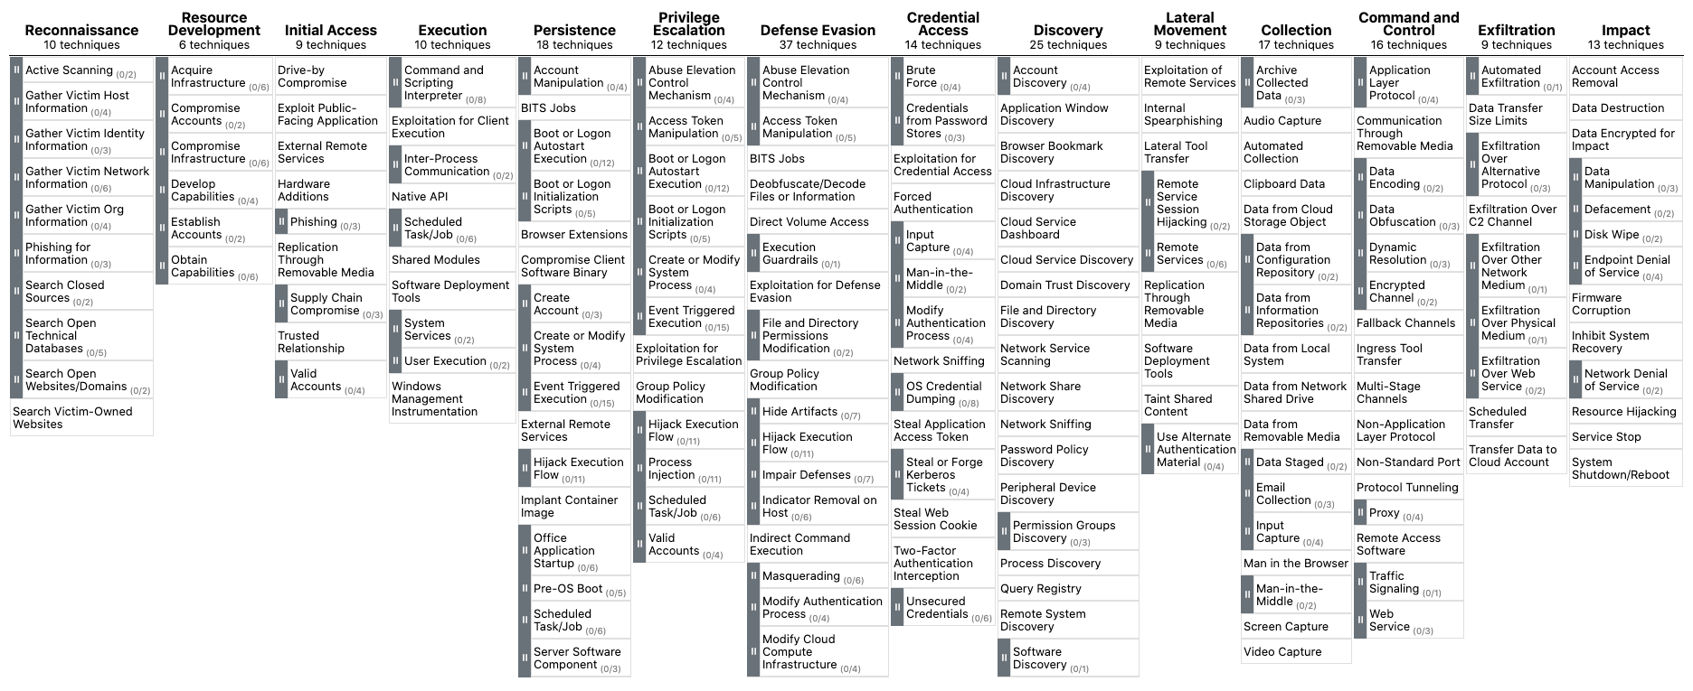

|  |  |  |  |
| --- | --- | --- | --- |
| Actors | Tatics | Techniques | Procedures |
|  |  |  |  |

#### Kill Chain details

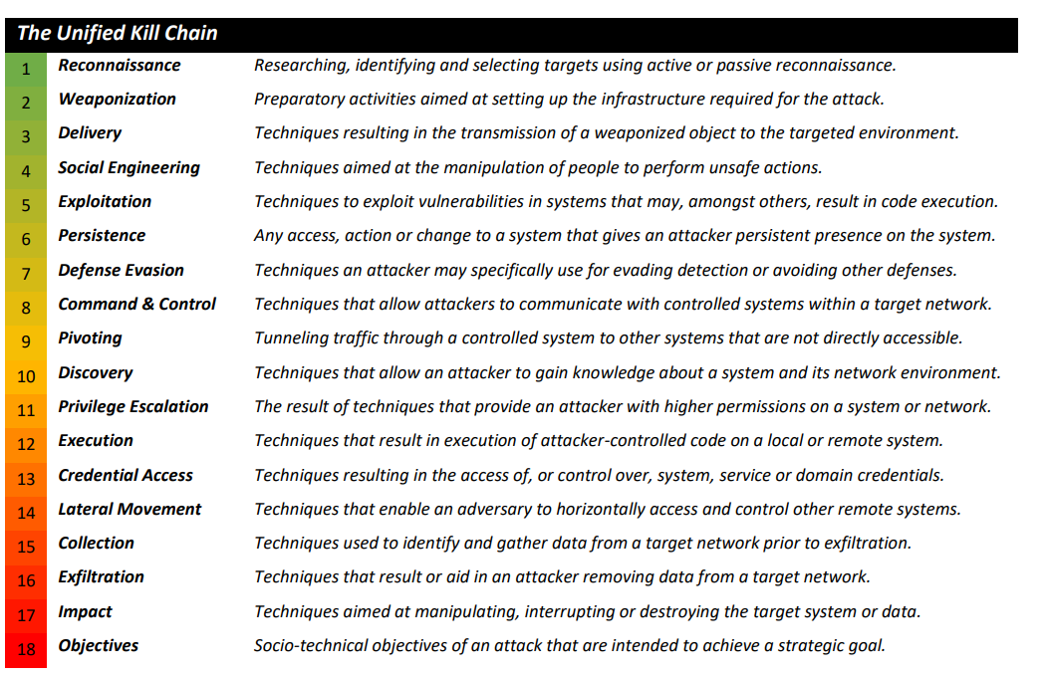

**Lorem ipsum**

|  |  |
| --- | --- |
| **Cyber Kill Chain** | **Details** |
|  |  |

### **Intelligence Findings**

Lorem Ipsum

#### Credentials Leaks

|  |  |  |
| --- | --- | --- |
| Source | Information | Impact |
|  |  |  |

#### Dark Web

|  |  |  |
| --- | --- | --- |
|  |  |  |
|  |  |  |

#### Deep Web

|  |  |  |
| --- | --- | --- |
|  |  |  |
|  |  |  |

#### MISP or Others

|  |  |  |
| --- | --- | --- |
|  |  |  |
|  |  |  |

### **ASSESSMENT**

#### Discover

#### Detect

#### Motivations

### **References**